OPTIMIZING USER GROUP AND ROLE MANAGEMENT WITH ACCESS CONTROL AND WORKFLOWS

**Team ID :** NM2025TMID14626

# Team Size : 4

**Team Leader :** Deivanai**.D Team member 1:** Kalaivani**.M Team member 2:** Gracy**.R**

**Team member 3 :** Priyadharshini**.D**

# TEAM INITIALIZATION

## Streamlining Ticket Assignment:

In a small project management team consisting of a Project Manager (Alice) and a Team Member (Bob), there is a need to efficiently manage project tasks and ensure accountability throughout the project lifecycle. The current system lacks clear role definitions, access controls, and a structured workflow, leading to confusion regarding task assignments and progress tracking**.**

## Objective:

To optimize user group and role management with access control and workflows, organizations should pursue four primary objectives: enhance security, increase operational efficiency, ensure compliance, and improve the user experience. Integrating automated workflows with a robust access control model, such as Role-Based Access Control (RBAC), is critical to achieving these goals.

## Milestone 1: Users Activity 1: Create Users

1. The first thing we need to do to create user is to Open service now.
2. After opening Servicenow we need to Open the instance.
3. Then Click on All present in the menu bar then search for users.
4. Select Users which is present under system security.
5. After selecting Users under system security, Click on new present in the right side top of the screen.
6. The page will appear as shown below with blank spaces
7. Fill the following details given in the figure shown below to create a user.

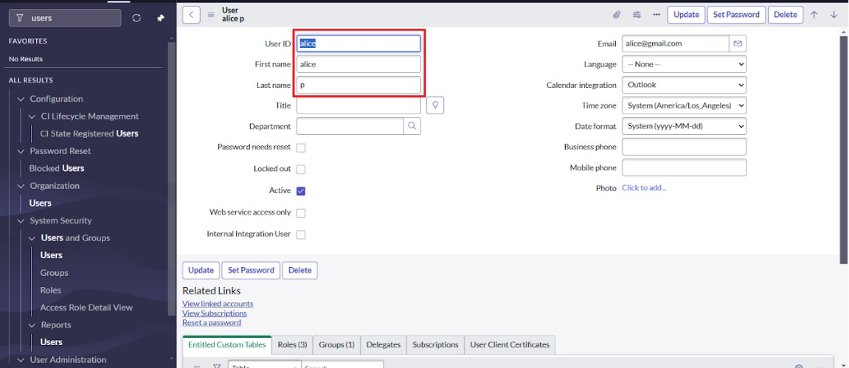

1. Then Click on submit to create the user.

## Activity 2: Create one more user

1. The instructions given above are the same for creating another user.
2. Fill the following details given in the figure shown below to create another user.

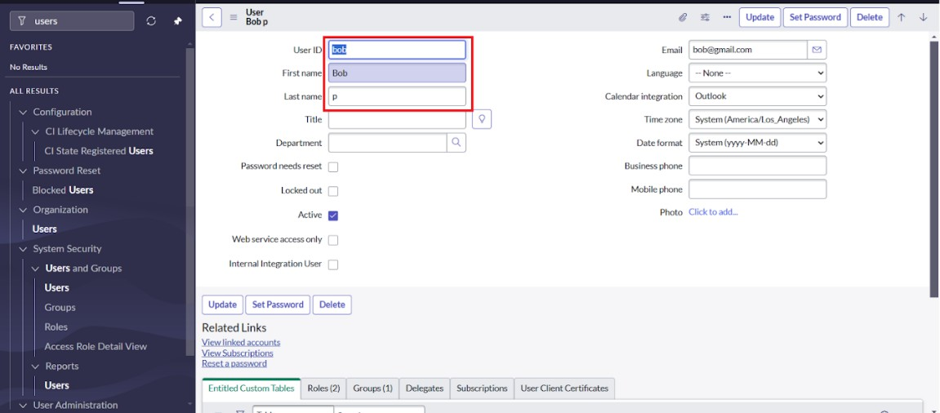

1. Then Click on submit to complete the creation.

## Milestone 2: Groups Activity 1: Create Groups

1. The first step is to Open service now.
2. Then Click on All menu option and search for groups in it.
3. Select groups which is present under system security.
4. Then Click on new option present in right top corner of the screen.
5. Fill the following details given in the figure to create a new group.

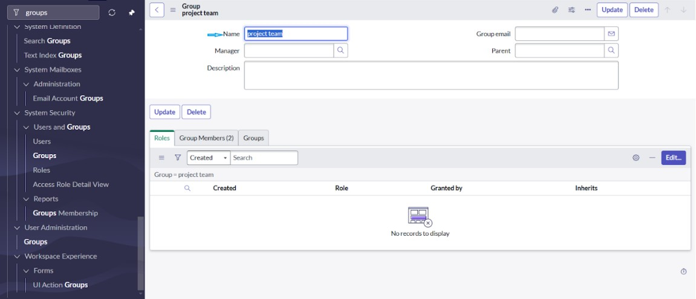

1. Finally Click on submit present in the top right cover of the screen.

## Milestone 3: Roles Activity 1: Create Roles

1. The first step is to Open service now.
2. Then Click on All menu and search for roles in it.
3. Select roles which is present under system security.
4. In that page Click on new to open a new page to create role.
5. The using the figure given Fill the following details to create a new role

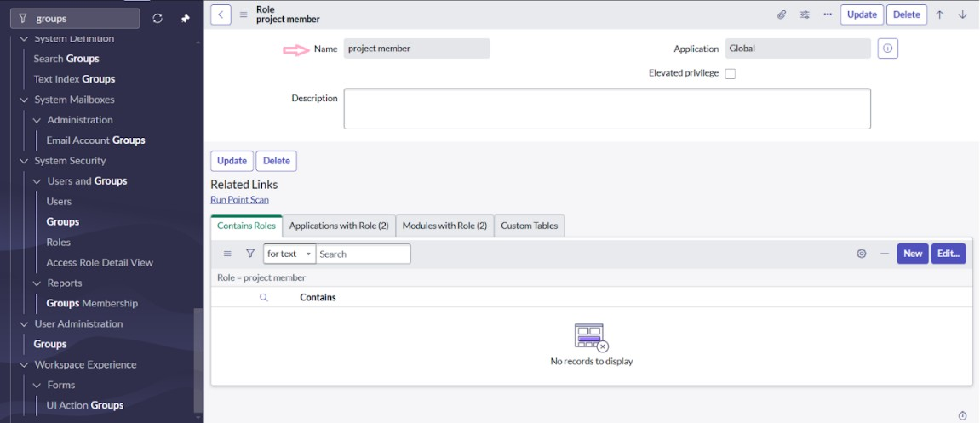

1. Then finally Click on submit to complete the process.

## Activity 2: Create another Roles

1. To Create another role follow the same instruction to open new page.
2. The with the help of the figure, fill the details of the role to be created.

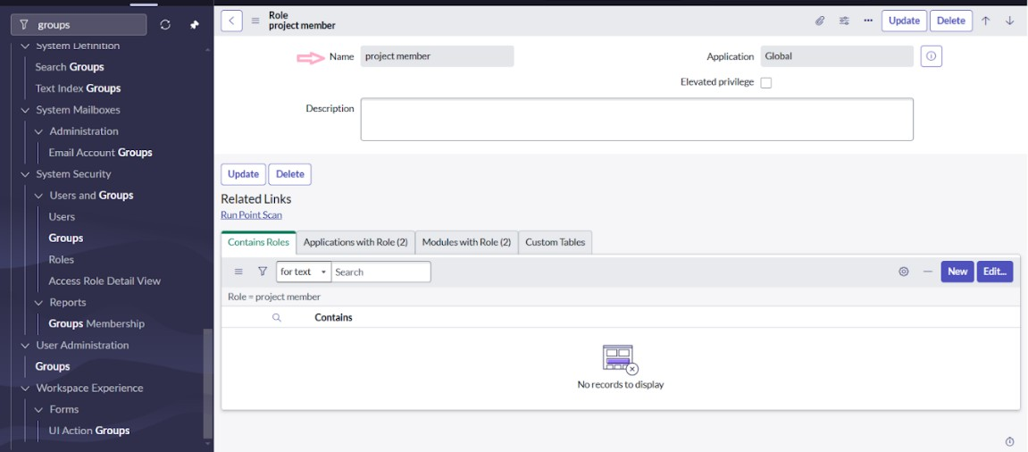

1. Then Click on submit to complete creating the role with name Platform_role

## Milestone 4: Table Activity: Create Table

1. First Open service now instances.
2. Then Click on All menu and search for tables in it.
3. In that Select tables which is present under system definition.
4. After opening tables, Click on new to create new table.
5. Fill the following details to create a new table.
   * Label : project table
   * Check the boxes Create module & Create mobile module
   * Under new menu name : project table

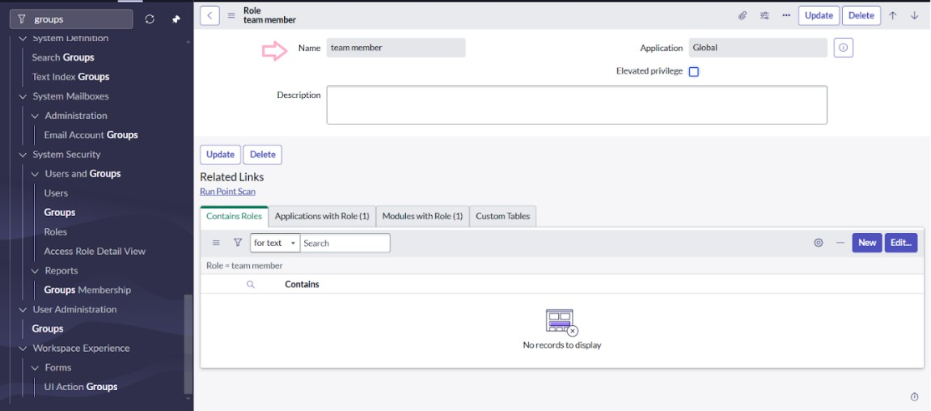

1. In the below we can see column option for the created table. Give columns as shown in the figure below

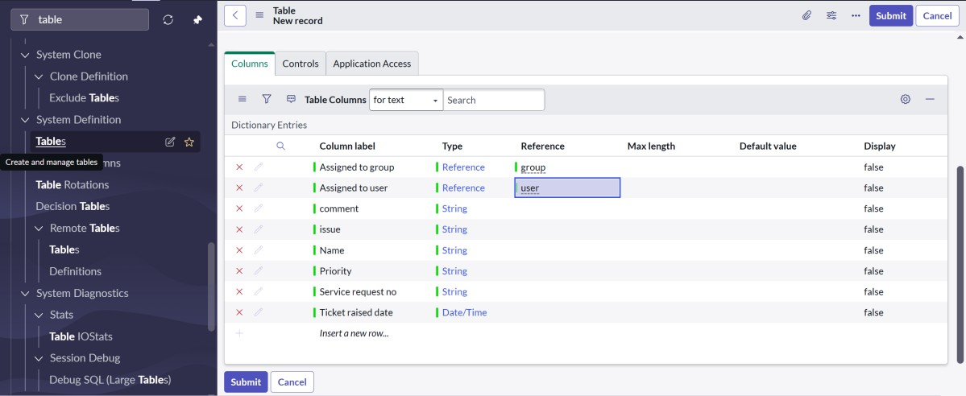

1. Click on submit to complete creating the table.
2. Create choices for the issue filed by using form design Choices are:
   * Unable to login to platform
   * 404 error
   * Regarding certificates
   * Regarding user expired

## Milestone 5: Assign users to groups

**Activity 1: Assign users to project team group**

1. Open service now.
2. Click on All >> search for groups
3. Select tables under system definition
4. Select the project team group
5. Under group members
6. Click on edit
7. Select alice p and bob p and save

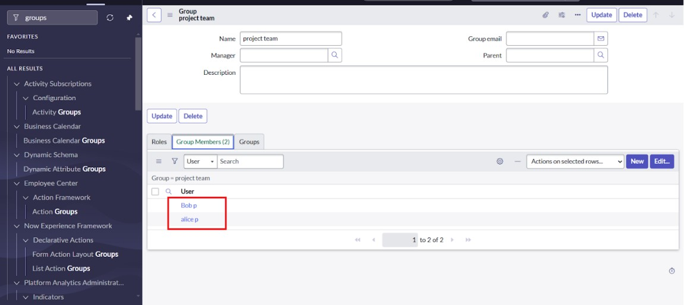

## Milestone 6: Assign role to user Activity 1: Assign roles to alice user

* 1. Open servicenow.Click on All >> search for user
  2. Select tables under system definition
  3. Select the project manager user
  4. Under project manager
  5. Click on edit
  6. Select project member and save
  7. click on edit add u_project_table role and u_task_table role
  8. click on save and update the form.

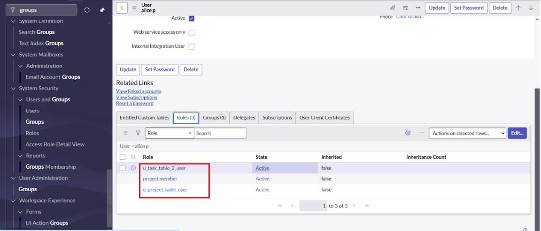

## Activity 2: Assign roles to bob user

1. Open ServiceNow. Click on All >> search for user
2. Select tables under system definition
3. Select the bob p user
4. Under team member
5. Click on edit
6. Select team member and give table role and save
7. Click on profile icon Impersonate user to bob
8. We can see the task table2.

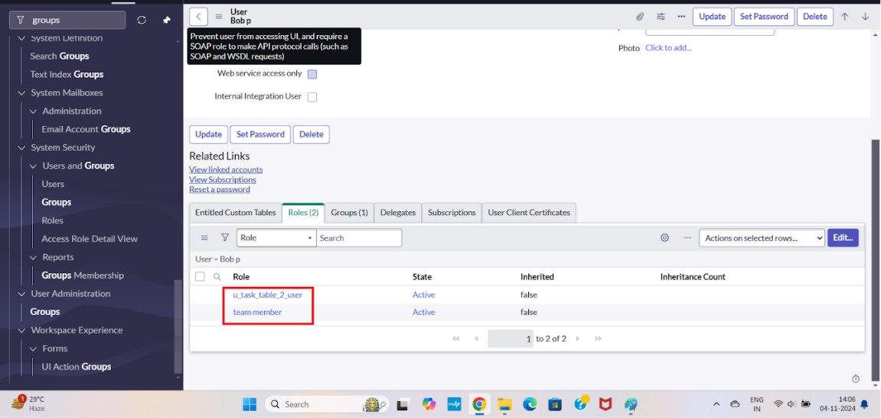

## Milestone 7: Application Access

**Activity 1: Assign table access to application**

1. while creating a table it automatically create a application and module for that table
2. Go to application navigator search for search project table application
3. Click on edit module
4. Give project member roles to that application
5. Search for task table2 and click on edit application.
6. Give the project member and team member role for task table 2 application

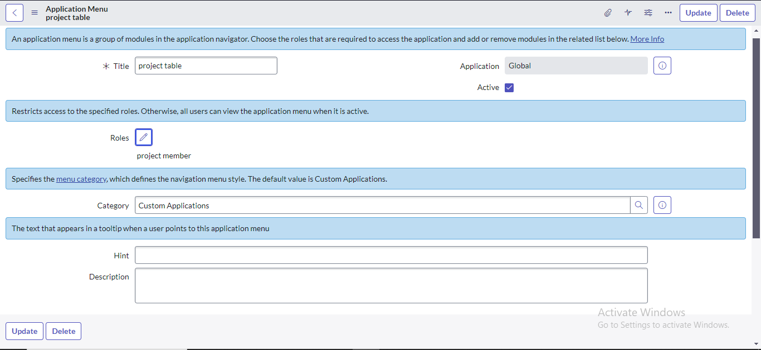

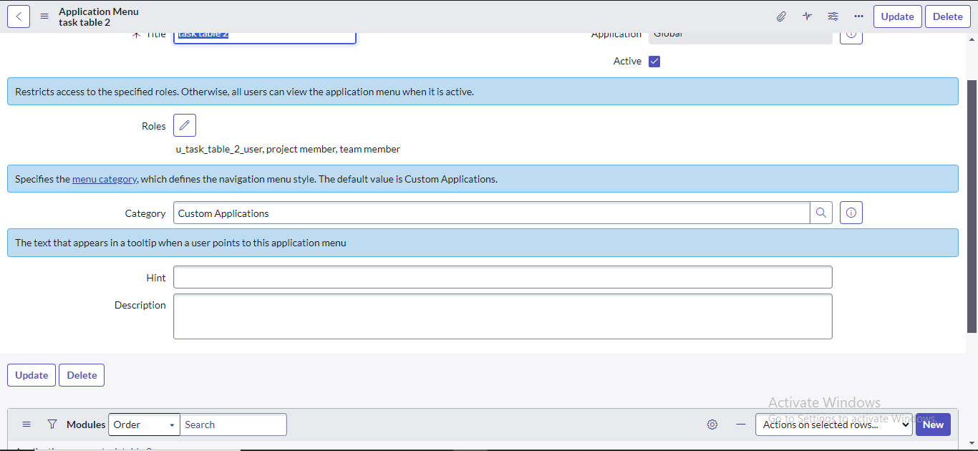

## Milestone 8: Create ACL Activity 1: Create ACL

1. Open service now.
2. Click on All >> search for ACL
3. Select Access Control(ACL) under system security
4. Click on elevate role
5. Click on new
6. Fill the following details to create a new ACL

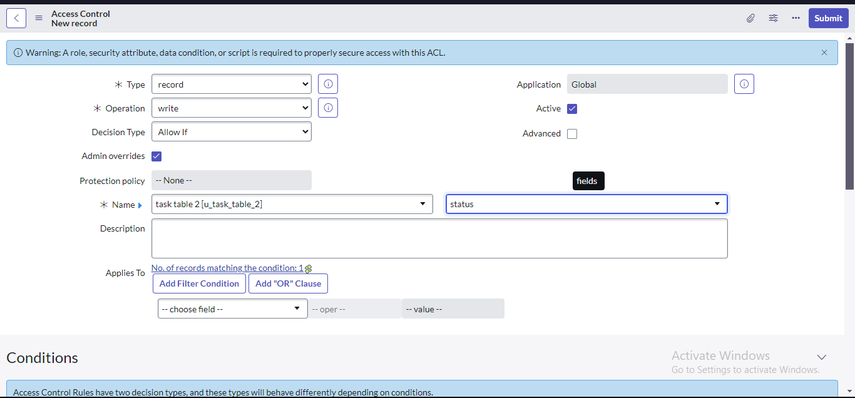

1. Scroll down under requires role
2. Double click on insert a new row
3. Give task table and team member role
4. Click on submit
5. Similarly create 4 acl for the following fields

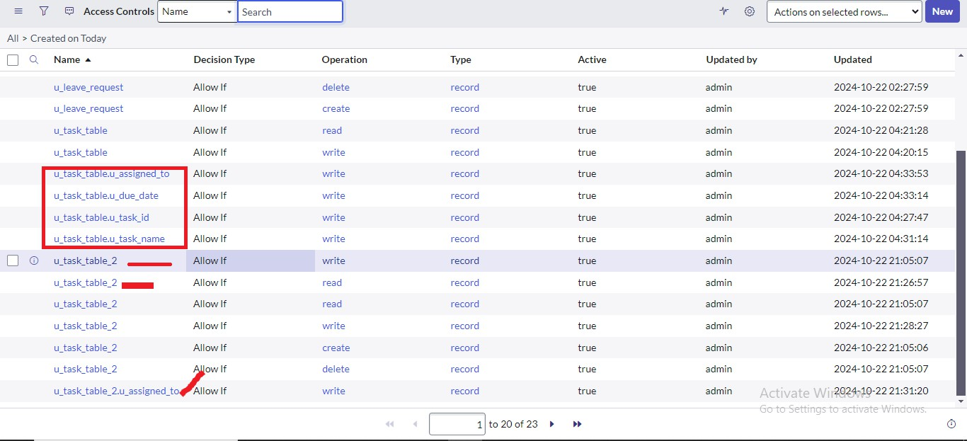

1. Click on profile on top right side
2. Click on impersonate user
3. Select bob user
4. Go to all and select task table2 in the application menu bar
5. Comment and status fields are have the edit access

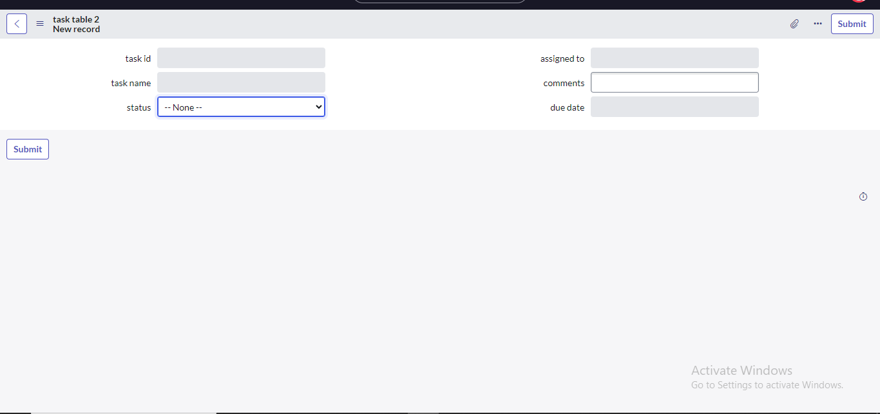

## Milestone 9: Flow

**Activity: Create a Flow to Assign operations ticket to group**

1. He first step is to Open service now.
2. Then Click on All >> search for Flow Designer
3. Next Click on Flow Designer under Process Automation.
4. After opening Flow Designer Click on new and select Flow.
5. Under Flow properties Give Flow Name as “ task table”.
6. Application should be Global.
7. Then Click build flow.

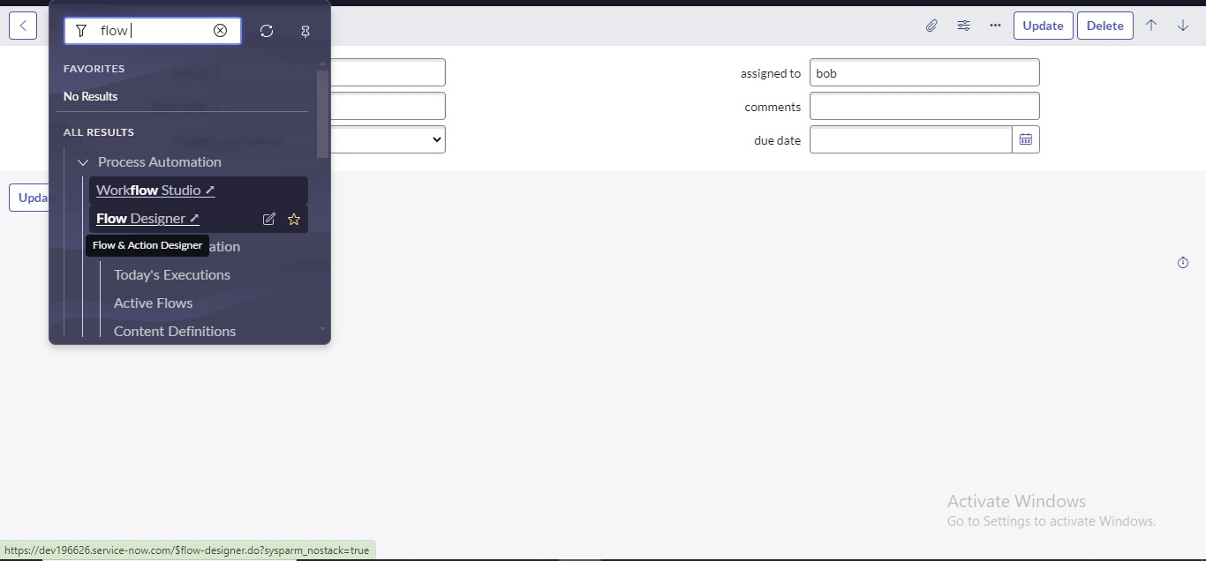

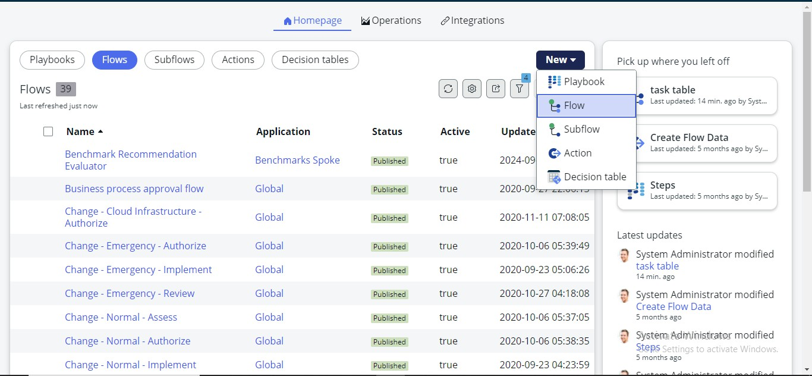

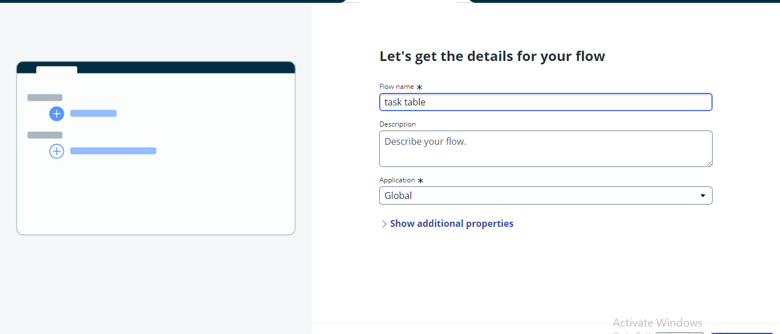

## next step:

1. Click on Add a trigger
2. Select the trigger in that Search for “create record” and select that.
3. Give the table name as “ task table ”.
4. Give the Condition as Field : status Operator :is Value : in progress Field : comments Operator :is Value : feedback Field : assigned to Operator :is Value : bob
5. After that click on Done**.**

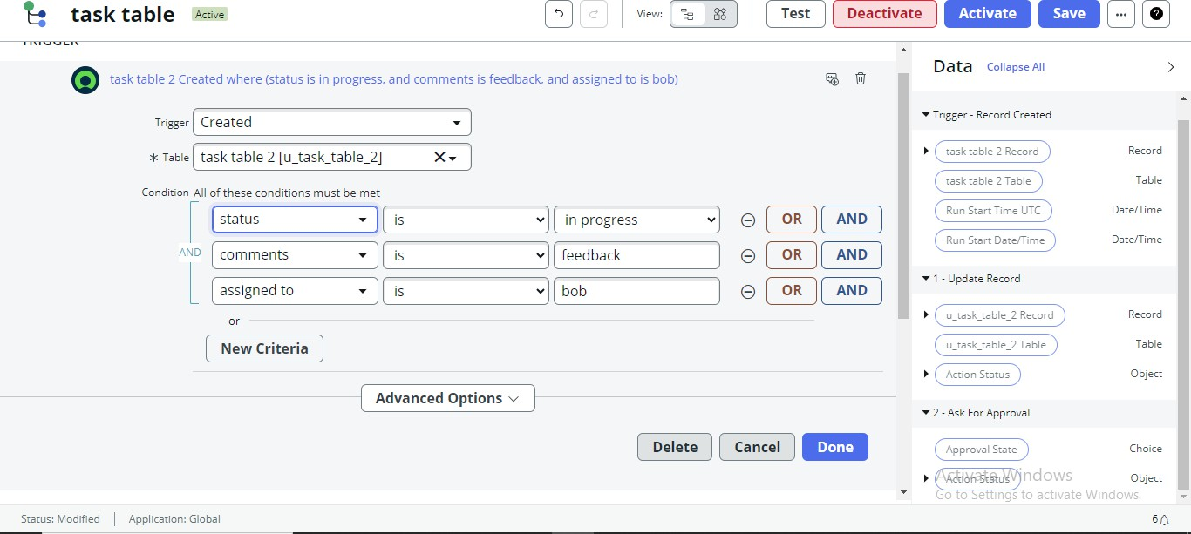

## Next step:

1. Click on Add an action.
2. Select action in that ,search for “ update records”.
3. In Record field drag the fields from the data navigation from Right Side(Data pill)
4. Table will be auto assigned after that
5. Add fields as “status” and value as “completed”
6. Click on Done.

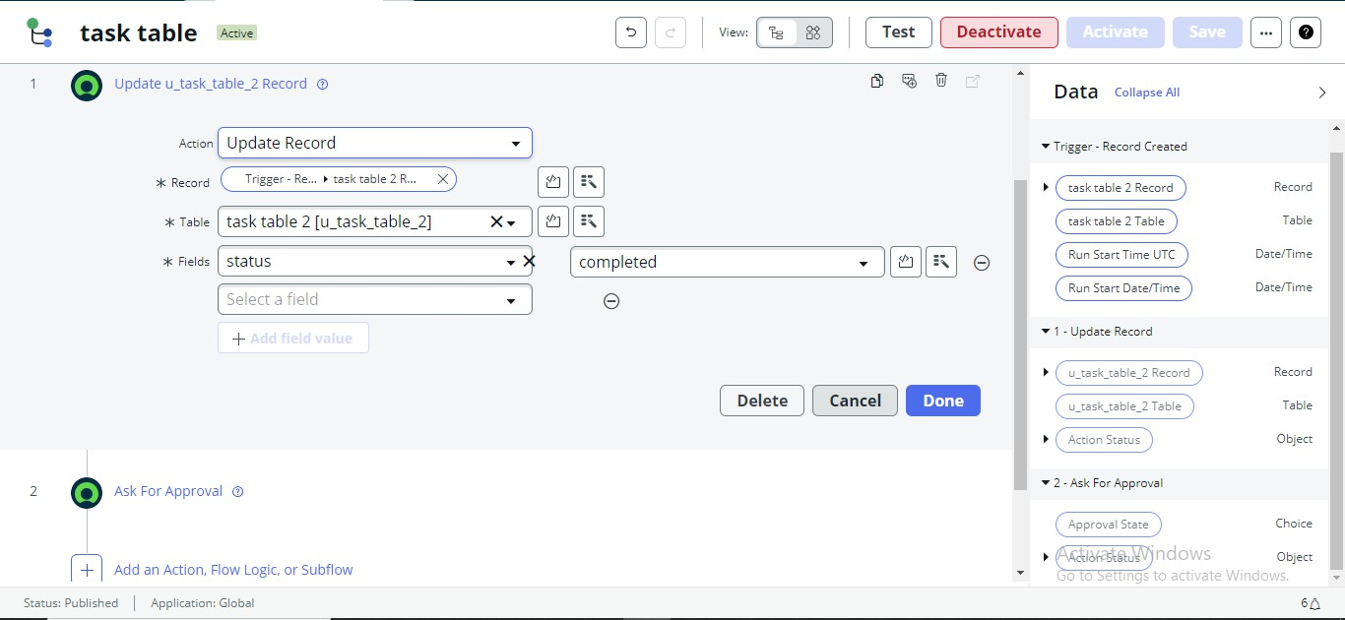

## Next step:

1. Now under Actions.
2. Click on Add an action.
3. Select action in that ,search for “ ask for approval ”.
4. In Record field drag the fields from the data navigation from Right side
5. Table will be auto assigned after that
6. Give the approve field as “ status”
7. Give approver as alice p
8. Click on Done.

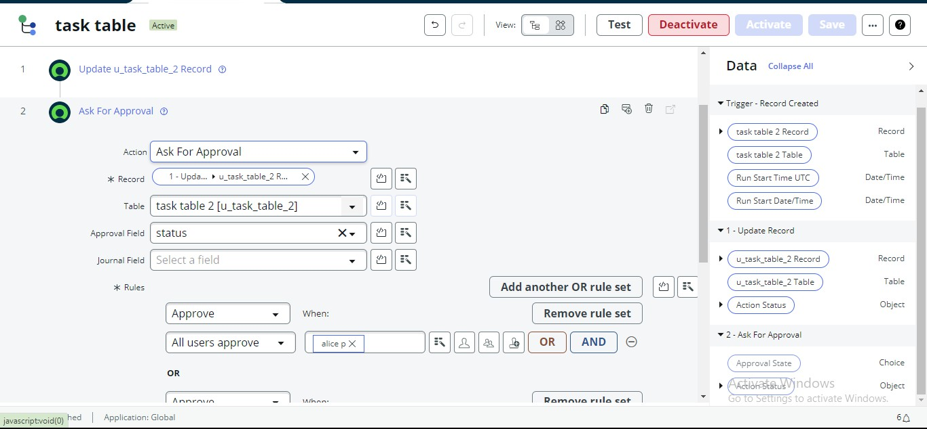

1. Go to application navigator search for task table.
2. It status field is updated to completed

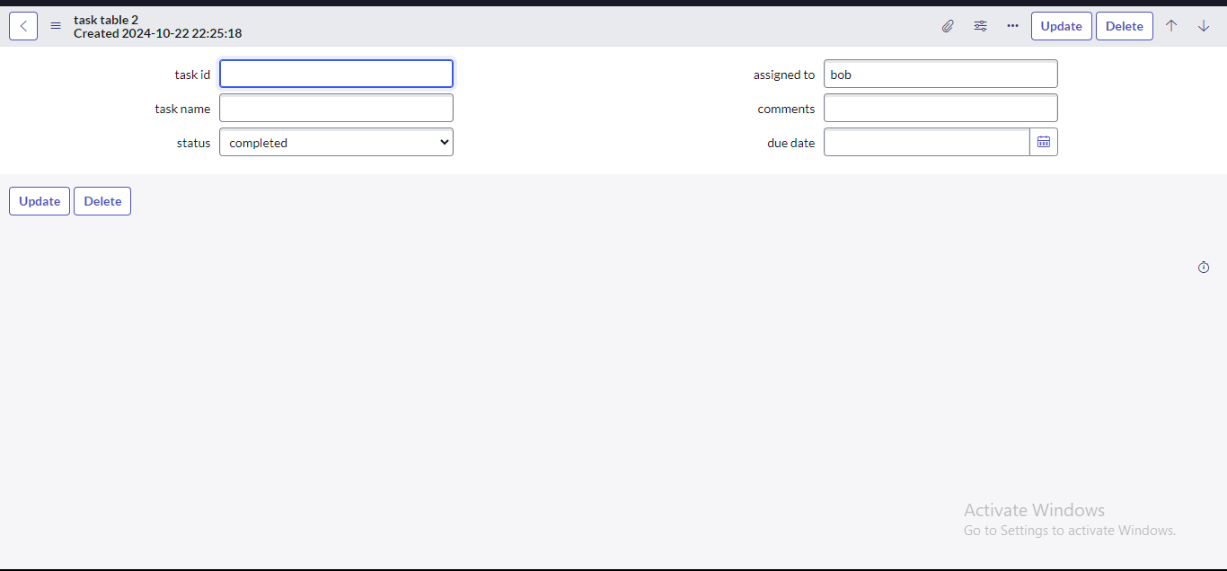

1. Go to application navigator and search for my approval
2. Click on my approval under the service desk.
3. Alice p got approval request then right click on requested then select approved

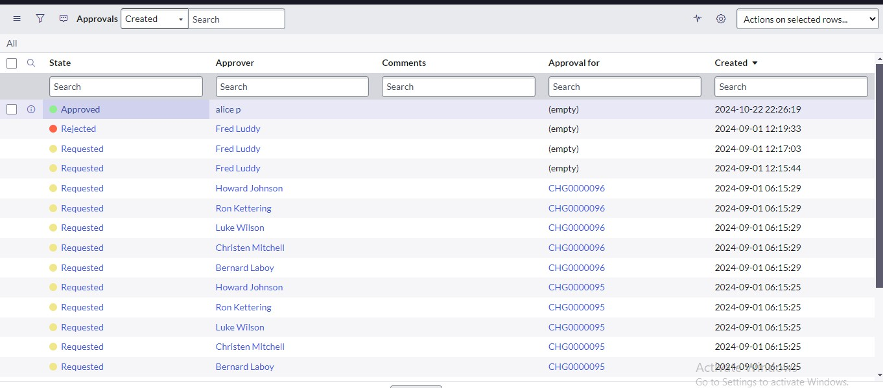

# CONCLUSION:

This scenario highlights a structured approach to project management, showcasing the roles of Alice and Bob within a defined workflow. With Alice's oversight and Bob's execution, the team effectively collaborates to ensure project success. The use of tables organizes key information, facilitating easy tracking of projects, tasks, and progress updates. Overall, this system promotes accountability, enhances communication, and leads to the successful completion of projects.